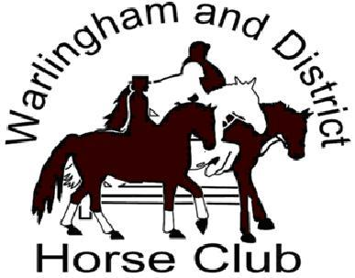

MOCK HUNT
SUNDAY 23rd SEPTEMBER 2018
Park Farm, Water Lane
Oxted RH8 0SA
10.30am for 11.00
By kind permission of Mr James & Mrs Amanda Skinner
WDHC Members £15. Visitors £25
Foot followers welcome
All jumps are optional
For more information contact
Mike Potts 01883 627405
Please see Warlingham & District Horse Club facebook page for updates.
************************

